XC4614 as Arduino Board using XC4464 or XC4414 as programmer
Thanks to the Arduino community, we can now use the powerful processor on the XC4614 as its own Arduino board. Bear in mind that the ESP13 chip on this board is only rated for 3.3V, and may be damaged if exposed to 5V signals.

Installing Arduino support for the Board

Make sure you are using Arduino 1.6.4 or later (I’ve got this working with Arduino 1.6.7).

Info for the Arduino Support Package can be found at:
https://github.com/esp8266/Arduino

TO install board support for ESP8266 (wifi Shield):
In File>Preferences>Additional Board Manager URLS add:

http://arduino.esp8266.com/stable/package_esp8266com_index.json

separating from existing entries with a comma.

Go to Tools>Boards>Boards Manager and type 'esp' in the search box- install ESP8266 by ESP8266 Community (this is about 150MB download and can take a while).

Choose ESP8266 from Boards, and check that the other default settings are as follows (these should be the defaults, except the Flash Size is 4M):

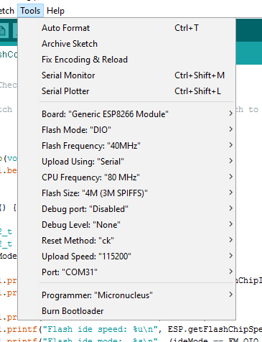

The Port that you use may be different, and corresponds to the COM port used by the XC4464 or XC4414.

Wiring it up:

To XC4464:
You will need WC6028 (plug to socket jumpers). Ensure that the voltage switch on the XC4464 is set to 3V3, as the ESP13 chip is only rated to 3.3V. Make the following connections:

XC4614 (Wifi Shield) | XC4464 (FTDI Board) | Function
5V (on Arduino side) | 5V | Power (there is a 3.3V regulator on the board)
G (on Arduino side) | GND | Ground
RX0 (on ESP13 side) | TXD | Data from XC4614
TX0 (on ESP13 side) | RXD | Data to XC4614
D0 (on ESP13 side) | No connection | Programming selector

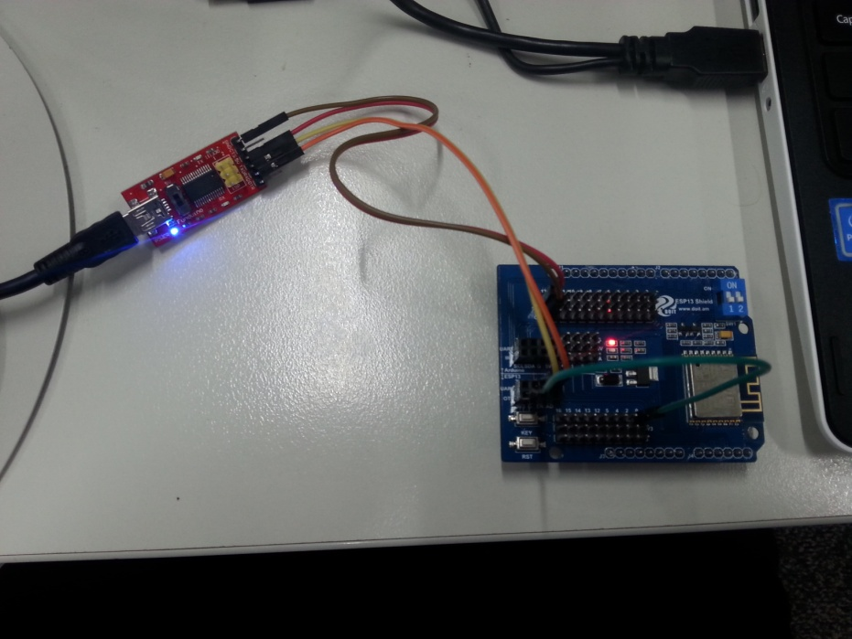
During the programming phase, the wire on D0 is connected to GND (G) on the shield (see green wire in picture above). This tells the shield to enter programming mode next time it is reset.

To Nano (XC4414):
If you’re using a Nano, make sure it has a sketch that doesn’t use the Serial port at all (the easiest way is to select File>New, and upload the empty sketch to the board). We’re just using the USB-Serial converter on the board, so the sketch doesn’t need to do anything.
XC4614 (Wifi Shield) | XC4414 (Nano) | Function
5V (on Arduino side) | 5V | Power (there is a 3.3V regulator on the board)
G (on Arduino side) | GND | Ground
RX (on Arduino side) | TX1 | Data from Nano board
TX (on Arduino side) | RX0 | Data to Nano board
D0 (on ESP13 side) | No connection | Programming selector- goes to G on XC4614

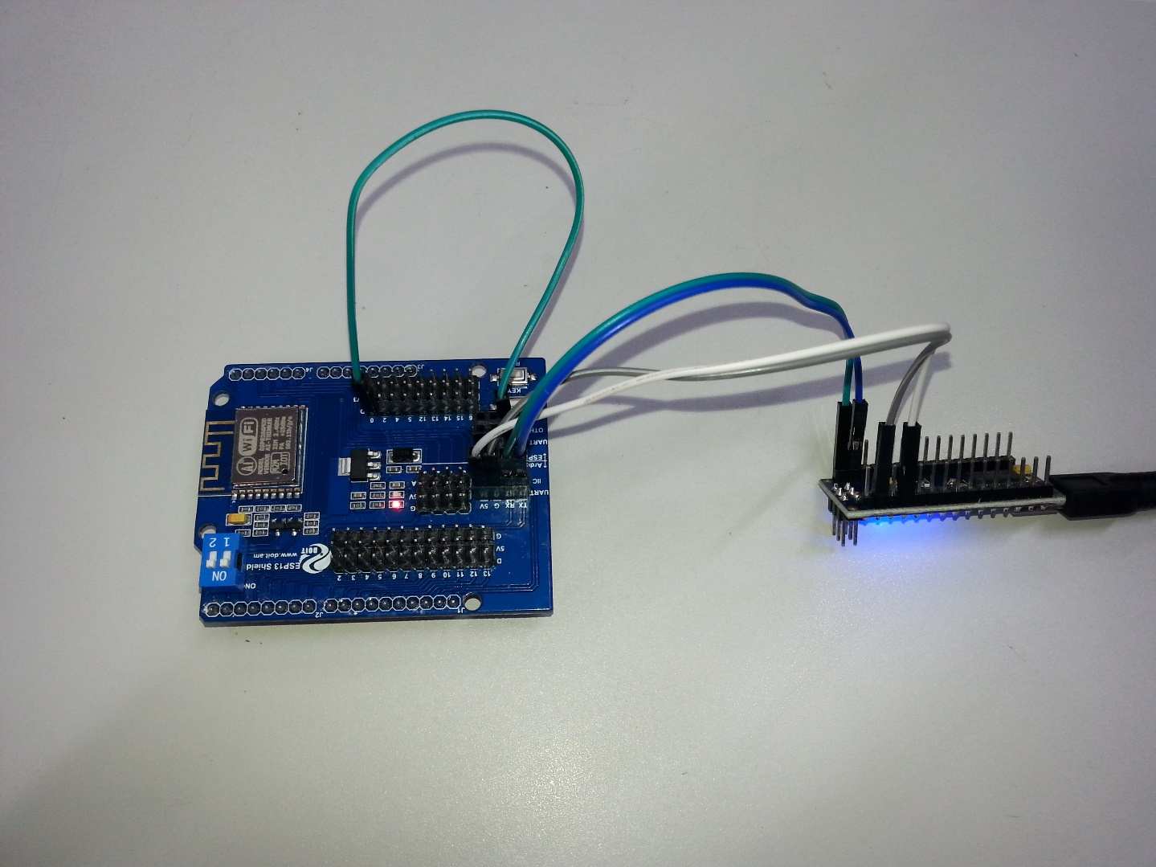
During the programming phase, the wire on D0 is connected to GND (G) on the shield (see green wire in picture above). This tells the shield to enter programming mode next time it is reset.

During normal operation, the green wire is not needed. If serial communication is not needed, then the orange and yellow wires will not be needed either. There are many example sketches- see File>Examples(Examples from Custom Libraries)>ESP8266WebServer>HelloServer for a basic web server to test that everything works as it should. Remember to change the Wifi network name and password to match yours.
The sequence to upload should be:
1. Connect green wire to GND.
2. Plug XC4464 into computer. (for subsequent uploads, press RST on module)
3. Select upload.
4. After a successful upload, the sketch will start automatically, so you don’t need to remove the green wire until you have finished tweaking your sketch. Go back to step 2 if you still need to upload another version.

Writing a Sketch:
See https://github.com/esp8266/Arduino/blob/master/doc/reference.md and https://github.com/esp8266/Arduino/blob/master/doc/libraries.md

You might also look at enabling OTA (over the air, or Wifi) programming. See https://github.com/esp8266/Arduino/blob/master/doc/ota_updates/readme.md for examples.

